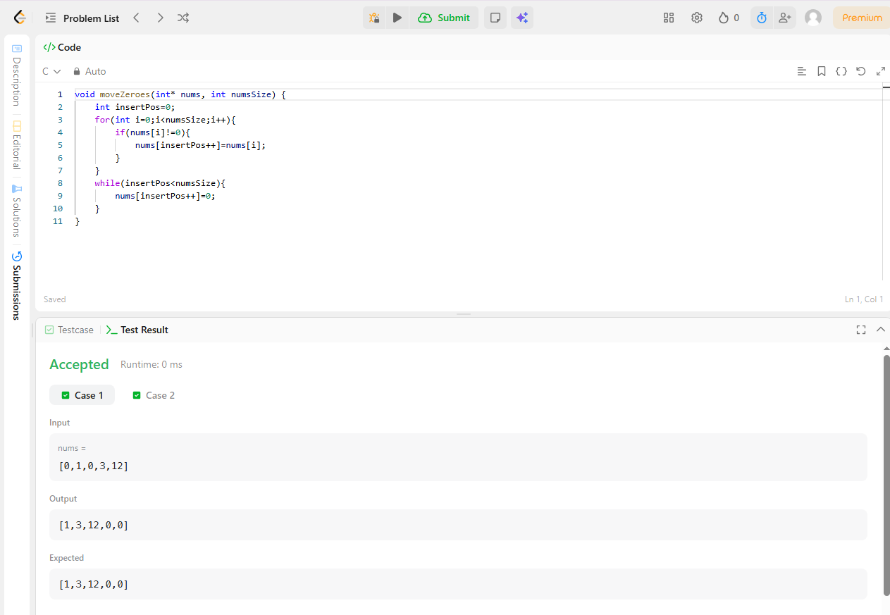
Question 1:

void moveZeroes(int* nums, int numsSize) {
int insertPos=0;
for(int i=0;i<numsSize;i++){
if(nums[i]!=0){
nums[insertPos++]=nums[i];
}
}
while(insertPos<numsSize){
nums[insertPos++]=0;
}
}

Question 2:
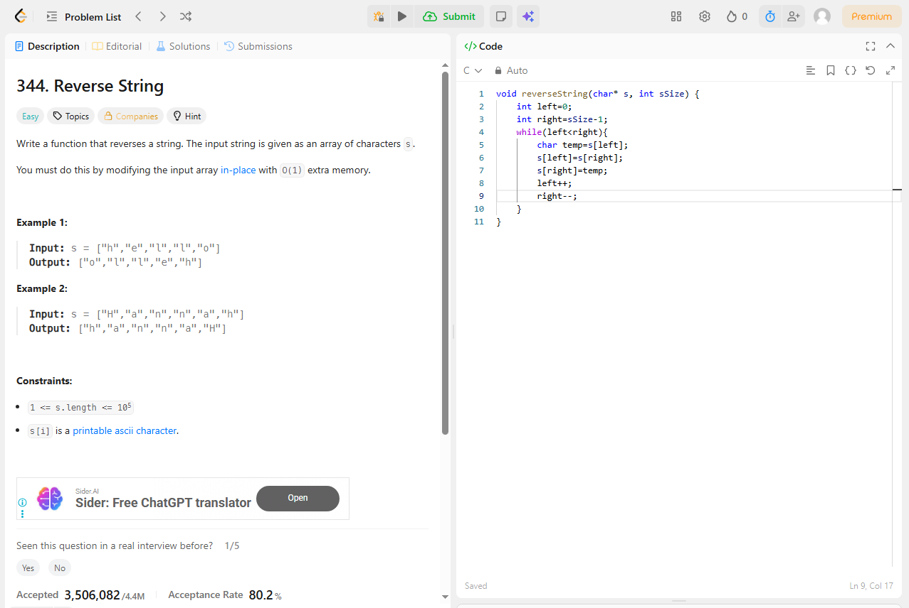

Question 3:

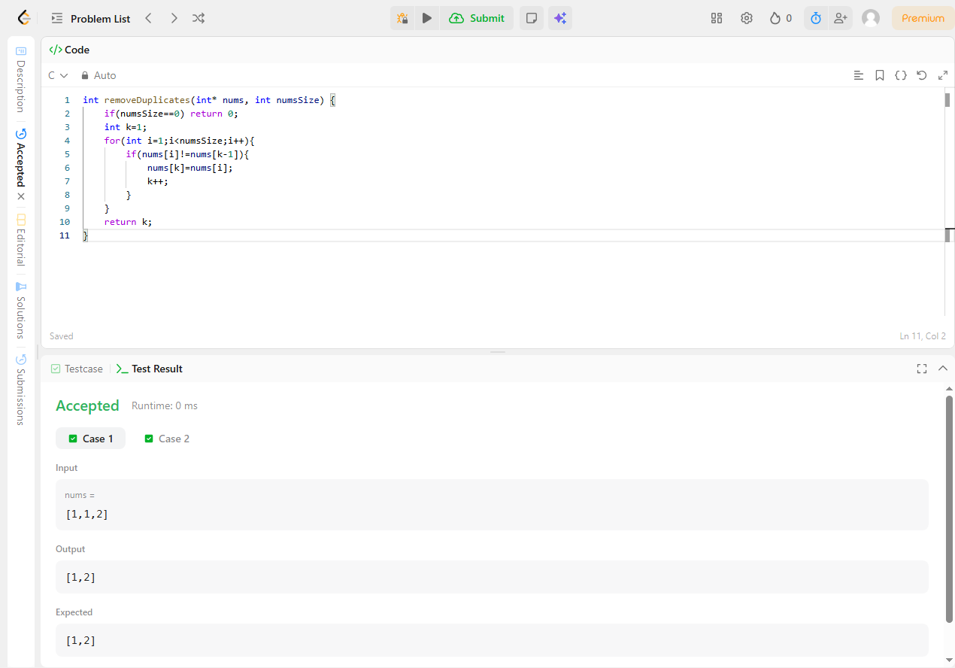

int removeDuplicates(int* nums, int numsSize) {
if(numsSize==0) return 0;
int k=1;
for(int i=1;i<numsSize;i++){
if(nums[i]!=nums[k-1]){
nums[k]=nums[i];
k++;
}
}
return k;
}

